**RETAIL STORE STOCK INVENTORY**

**ANALYSIS**

**INTRODUCTION**

**Overview**

The Retail Store Stock Inventory Analytics project in Tableau is a data-driven initiative that focuses on analyzing and visualizing stock inventory data in the retail industry. By leveraging Tableau's powerful visualization capabilities, this project aims to provide insights and actionable information to optimize inventory management, reduce costs, and improve overall efficiency.

**PURPOSE**

**Project Objectives**

By the end of this project you will:

* Know fundamental concepts and can work on the tableau.
* Gain a broad understanding of plotting different graphs.
* Able to create meaningful dashboards.

Technical Architecture:

**Literature Survey**

**Existing problem**

The existing problem in retail store stock inventory management is often characterized by challenges such as stockouts, excess stock, inefficient replenishment, inaccurate demand forecasting, and suboptimal inventory levels. These issues can lead to lost sales, increased costs, poor customer satisfaction, and inefficient supply chain operations.

**Proposed solution**

In the Retail Store Stock Inventory Analytics project, the proposed solution involves leveraging Tableau's data visualization and analytics capabilities to address the existing problems in stock inventory management.

The project aims to provide an integrated solution that encompasses the following key components:

Data Integration and Cleaning: The project involves integrating and cleaning stock inventory data from various sources, including sales transactions, inventory records, and supplier information. This ensures data consistency and reliability for analysis.

Stock Inventory Analytics: Utilizing Tableau's features, the project analyzes stock inventory data to gain insights into inventory levels, stockouts, excess stock, and inventory turnover ratios. It applies statistical techniques, trend analysis, and forecasting models to identify patterns, anomalies, and opportunities for improvement.

**THEORITICAL ANALYSIS**

**Block Diagram**

**+---------------------------+**

**| Stock Inventory |**

**| Analysis |**

**+---------------------------+**

**|**

**|**

**+-------------------------------+**

**| Data Collection |**

**+-------------------------------+**

**|**

**|**

**+-------------------------------+**

**| Data Preprocessing |**

**+-------------------------------+**

**|**

**|**

**+-------------------------------+**

**| Data Exploration |**

**+-------------------------------+**

**|**

**|**

**+-------------------------------+**

**| Statistical Analysis |**

**+-------------------------------+**

**|**

**|**

**+-------------------------------+**

**| Inventory Forecast |**

**+-------------------------------+**

**|**

**|**

**+-------------------------------+**

**| Performance Metrics |**

**+-------------------------------+**

**|**

**|**

**+-------------------------------+**

**| Reporting and |**

**| Visualization |**

**+-------------------------------+**

**Experimental Investigations**

Comparative Analysis of Forecasting Models: Compare the performance and accuracy of different forecasting models, such as time series models, regression models, or machine learning algorithms, to identify the most effective approach for demand forecasting in the specific retail context.

A/B Testing for Replenishment Strategies: Conduct A/B testing to evaluate the impact of different replenishment strategies on key metrics such as stockouts, excess stock, and profitability. Compare the results of different approaches, such as fixed-order quantity vs. dynamic reorder point, to determine the optimal strategy.

Supplier Performance Evaluation: Analyze historical supplier data to assess the impact of supplier performance on stock inventory. Investigate correlations between supplier metrics, such as lead time, on-time deliveries, and product quality, and their influence on inventory levels and customer satisfaction.

Simulation Analysis for Scenario Planning: Utilize simulation techniques to analyze different scenarios and evaluate their impact on stock inventory. Simulate changes in customer demand, supplier performance, or market conditions to assess the robustness of the inventory management system and identify potential vulnerabilities.

User Feedback and Usability Testing: Gather feedback from end-users, such as inventory managers or decision-makers, regarding the usability and effectiveness of the stock inventory analytics solution. Conduct usability testing to identify areas for improvement in terms of interface design, functionality, and ease of use.

**Project Flow**

To accomplish this, we have to complete all the activities listed below,

**Define Problem / Problem Understanding**

* Specify the business problem
* Business requirements
* Literature Survey
* Social or Business Impact.

**Data Collection & Extraction from Database**

* Collect the dataset,
* Connect MySQL with Tableau Desktop

**Data Preparation**

* Prepare the Data for Visualization

**Data Visualizations**

* No of Unique Visualizations

**Dashboard**

* Responsive and Design of Dashboard

**Story**

* No of Scenes of Story

**Report**

* Creating a report

**Performance Testing**

* Amount of Data Rendered to DB
* Utilization of Data Filters
* No of Calculation Fields
* No of Visualizations/ Graphs

**Web Integration**

* Dashboard and Story embed with UI With Flask

**Project Demonstration & Documentation**

* Record explanation Video for project end to end solution
* Project Documentation-Step by step project development procedure

**Advantages and Disadvantages:**

Improved Inventory Management: By leveraging data analytics and forecasting techniques, the project enables better inventory management. This leads to optimized stock levels, reduced stockouts, minimized excess stock, and improved overall operational efficiency.

Enhanced Decision Making: The project provides valuable insights into stock inventory trends, demand patterns, and supplier performance. These insights empower decision-makers to make informed and strategic decisions related to inventory replenishment, pricing, promotions, and supplier selection, leading to improved profitability and customer satisfaction.

Data Visualization for Communication: Utilizing Tableau for visualization allows for the creation of interactive and visually appealing dashboards and reports. This facilitates effective communication of complex stock inventory analytics to stakeholders, enabling easy interpretation of data and fostering data-driven decision making across the organization.

Disadvantages of the Retail Store Stock Inventory Analytics project:

Data Complexity and Quality Issues: Dealing with large and diverse datasets from multiple sources can present challenges in terms of data complexity, inconsistencies, and quality issues. Ensuring data accuracy, completeness, and integrity may require significant effort in data cleaning, integration, and validation.

Technical Expertise and Resources: Implementing the project effectively requires technical expertise in data analytics, statistical modeling, and visualization tools like Tableau. Organizations may need to invest in skilled personnel, training, and resources to handle the technical aspects of data analysis and visualization.

Scalability and Adaptability: As the retail business grows or undergoes changes, the project needs to be scalable and adaptable to accommodate larger datasets, expanding product ranges, and evolving business needs. Scaling up the analysis and forecasting models, as well as maintaining data quality and relevance, can be complex and resource-intensive.

**Applications**

The Retail Store Stock Inventory Analytics project can be applied in various retail sectors, including grocery stores, fashion retailers, electronic retailers, and more, to optimize inventory management and improve operational efficiency.

It enables retailers to make data-driven decisions regarding inventory replenishment, pricing, promotions, and supplier management, leading to increased profitability and customer satisfaction.

The project's application can result in reduced stockouts, minimized excess stock, improved demand forecasting, and better supplier performance evaluation, ultimately enhancing the overall competitiveness of the retail business.

**Future Scope**

The future scope of the Retail Store Stock Inventory Analytics project includes integrating real-time data for up-to-date insights, advanced forecasting techniques for improved accuracy, and an automated replenishment system to streamline processes.

Integration with e-commerce platforms can provide visibility into online sales and inventory availability, ensuring efficient order fulfillment and preventing stockouts.

Predictive maintenance capabilities can be added to identify potential issues and minimize disruptions in inventory storage and infrastructure.

Expanding the project to include supply chain optimization enables retailers to address inefficiencies and optimize transportation routes, vendor management, and inventory distribution.

Continuously enhancing data visualization and reporting features empowers users to explore data from multiple dimensions and gain deeper insights into stock inventory analytics.

### Collect The Dataset

**Activity 1.1: Understand the data**

Check out the below link to understand the dataset in detail:

**Activity 2: Connect Microsoft Excel and Tableau with the dataset**

Explanation video link:

### Data Preparation

Data preparation for Tableau involves the process of organizing, cleaning, and transforming raw data into a format that can be effectively visualized and analysed within the Tableau software. This includes tasks such as data cleaning, data integration, data formatting, and data aggregation. The goal is to ensure that the data is accurate, consistent, and structured in a way that enables meaningful insights and visualizations in Tableau.

### Prepare The Data For Visualization

Preparing the data for visualization involves cleaning the data to remove irrelevant or missing data, transforming the data into a format that can be easily visualized, exploring the data to identify patterns and trends, filtering the data to focus on specific subsets of data, preparing the data for visualization software, and ensuring the data is accurate and complete. This process helps to make the data easily understandable and ready for creating visualizations to gain insights into the performance and efficiency.

### Data Visualization

Data visualization is the process of creating graphical representations of data in order to help people understand and explore the information. The goal of data visualization is to make complex datasets more accessible, intuitive, and easier to interpret. By using visual elements such as charts, graphs, and maps, data visualizations can help people quickly identify patterns, trends, and outliers in the data.

### No Of Unique Visualizations (Filters Applied)

The number of unique visualizations that can be created with a given dataset. Some common types of visualizations that can be used to analyse the data include bar charts, line charts, heat maps, scatter plots, pie charts, maps, etc. These visualizations can be used to compare performance, track changes over time, show distribution, and show relationships between variables.

**Activity 1.1:** Total number of sales in each month of a year

**Activity 1.2:** Total Amount of inventory over the four quaters

**Activity 1.3:** Year Wise Price

**Activity 1.4:** Monthly Sales

**Activity 1.5:** Calculation Of Monthly Stokes

**Activity 1.6:** Monthly Revenue

**Activity 1.7:** Total Stock , Price , Sales , Revenue

**Explanation video link :**

<https://drive.google.com/file/d/1sRHwwEgM4kG8SUGQcligR7ySh7ltct9-/view?usp=sharing>

<https://drive.google.com/file/d/1EGd0aBoeeHK0jF55VPEHk64Fdw1CrON1/view?usp=sharing>

<https://drive.google.com/file/d/1Fxftl1qfYpsfxByK6gwrSOi6fVy5UVLe/view?usp=sharing>

<https://drive.google.com/file/d/1HHAGVf-EtJFcCG68uUhMjsaeZg6iqkqs/view?usp=sharing>

<https://drive.google.com/file/d/1sdZ4dxfCQXkBys0rsz-MoHHKPJlc3SsB/view?usp=sharing>

<https://drive.google.com/file/d/1qs9nP3_WSX5F8f6aropbSK91wmxP97xd/view?usp=sharing>

<https://drive.google.com/file/d/1CYXAmGwraY906WWSe-hyaJ45wwxh0uS3/view?usp=sharing>

### Dashboard

A dashboard is a graphical user interface (GUI) that displays information and data in an organized, easy-to-read format. Dashboards are often used to provide real-time monitoring and analysis of data and are typically designed for a specific purpose or use case.

Dashboards can be used in a variety of settings, such as business, finance, manufacturing, healthcare, and many other industries. They can be used to track key performance indicators (KPIs), monitor performance metrics, and display data in the form of charts, graphs, and tables.

### Story

A data story is a way of presenting data and analysis in a narrative format, with the goal of making the information more engaging and easier to understand. A data story typically includes a clear introduction that sets the stage and explains the context for the data, a body that presents the data and analysis in a logical and systematic way, and a conclusion that summarizes the key findings and highlights their implications. Data stories can be told using a variety of mediums, such as reports, presentations, interactive visualizations, and videos.

Explanation video link of Dashboard and Story:

<https://drive.google.com/file/d/1sSkBsl9GLGZPjl2WVSPMKVYzmiW2igLn/view?usp=sharing>

<https://drive.google.com/file/d/1ww10m6JPNayqog2ivRmQn-YnqgqCl-qW/view?usp=sharing>

// Paste Dashboard snip here

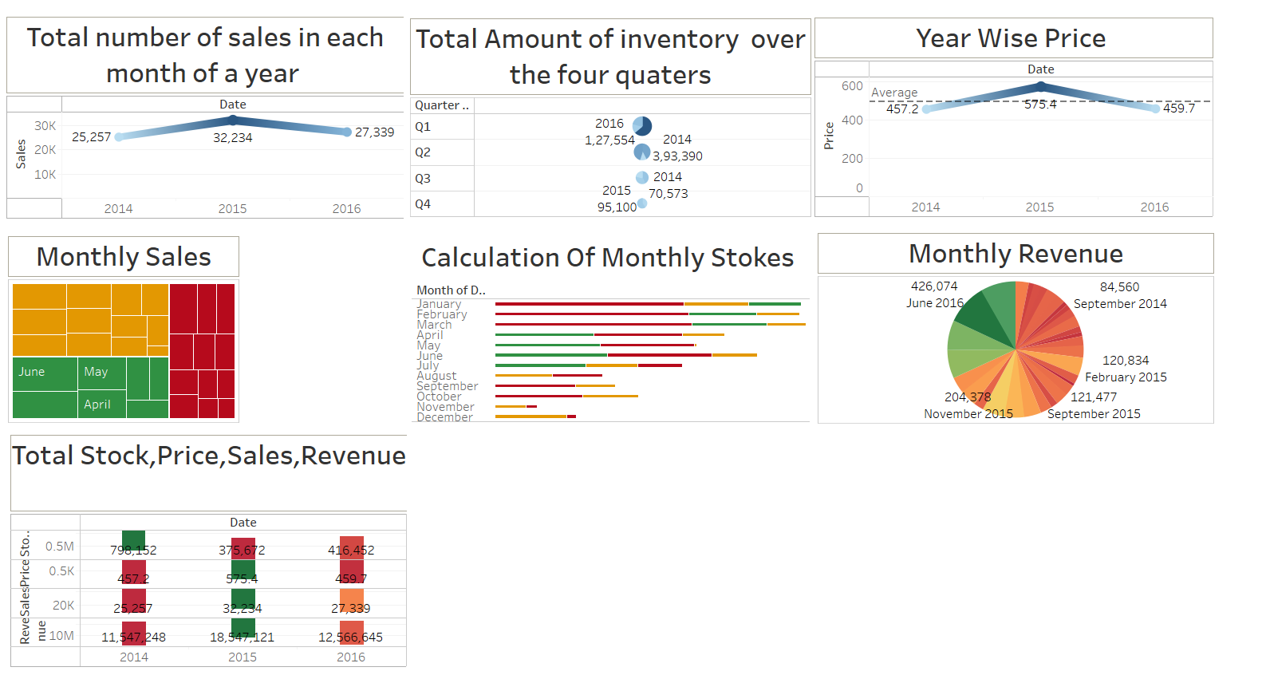

// Paste Story Snip here ( Include every visualization)

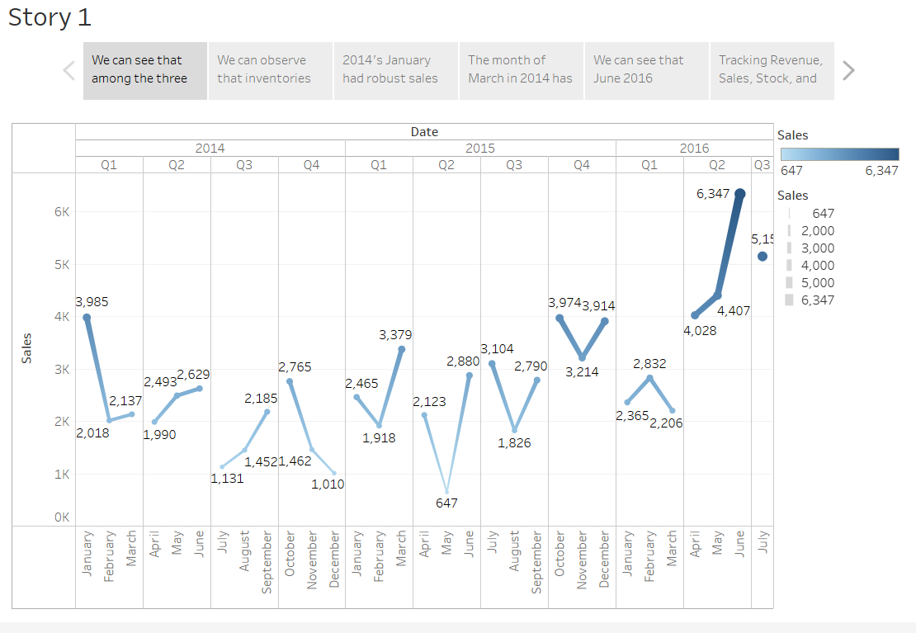

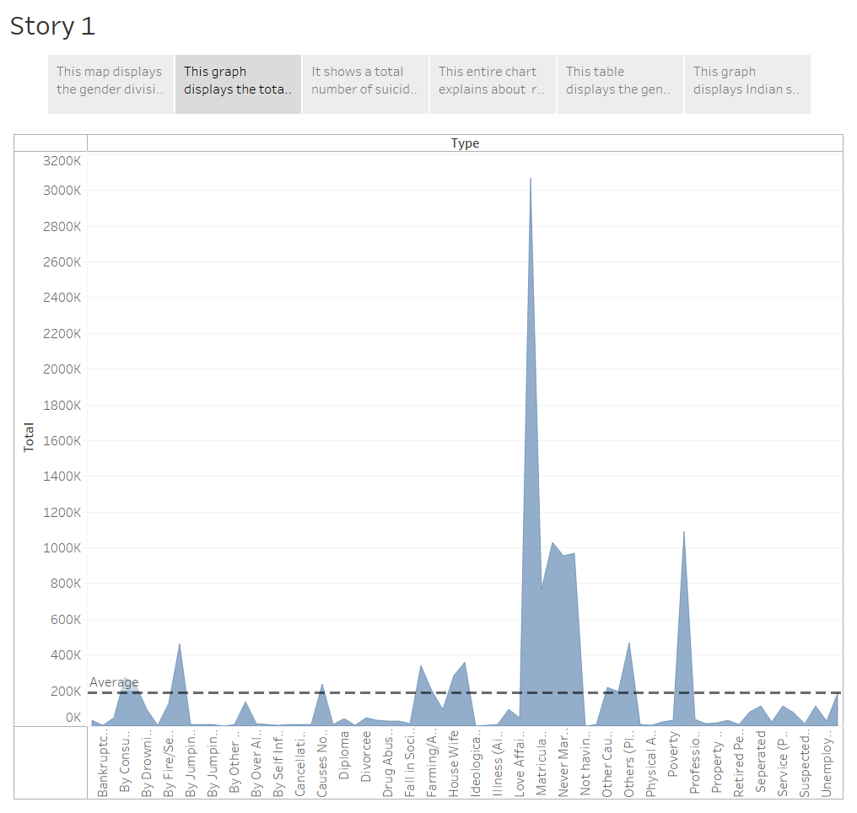

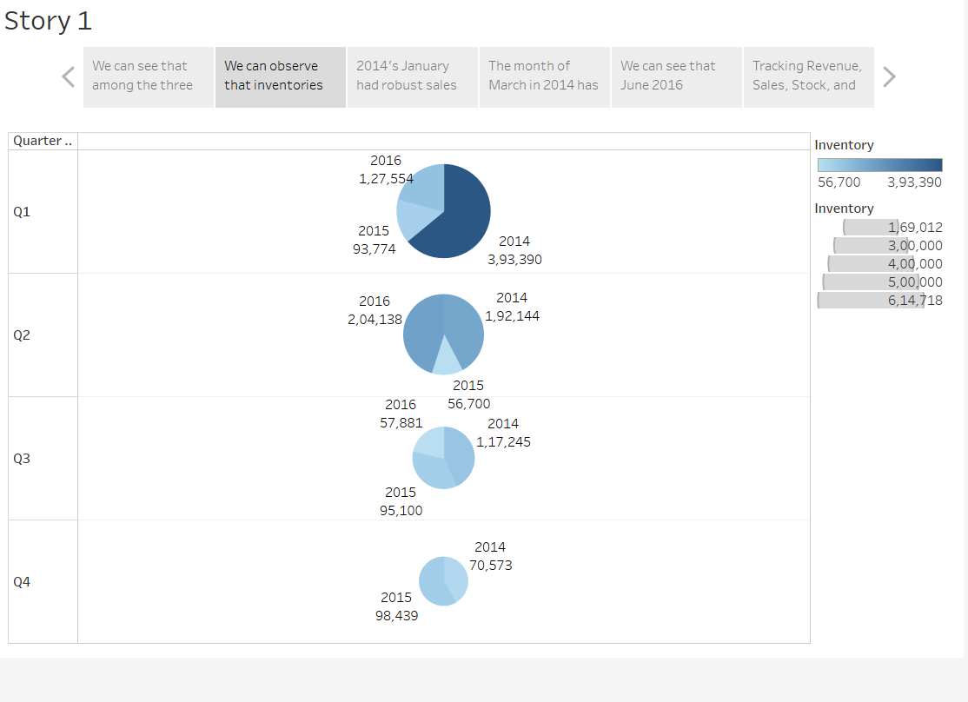

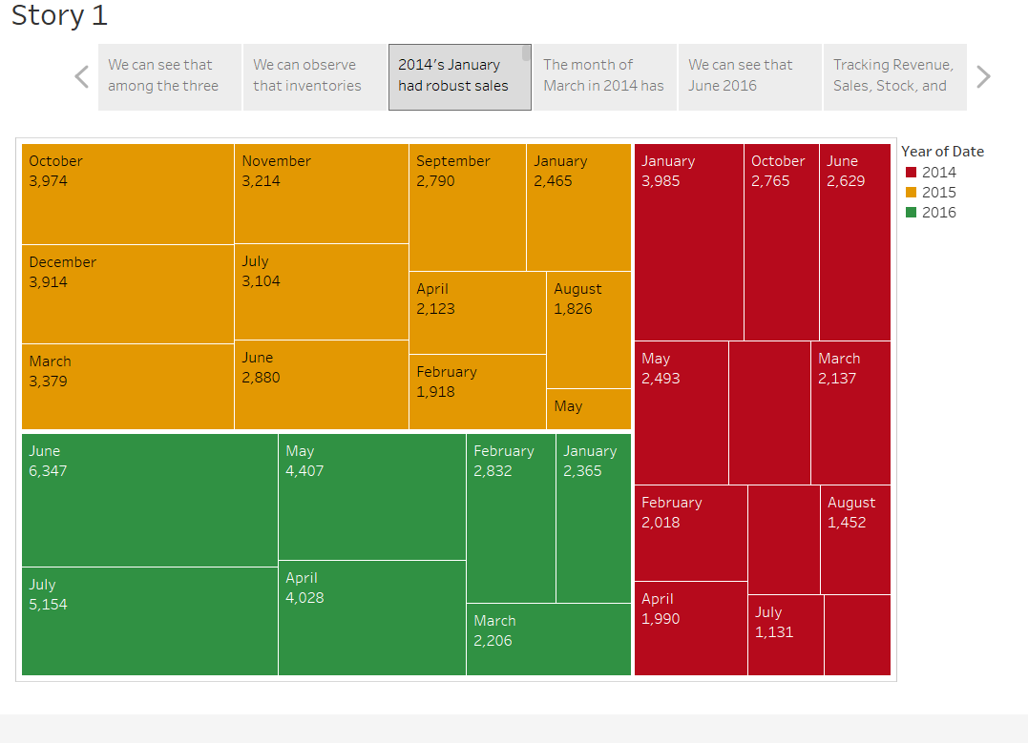

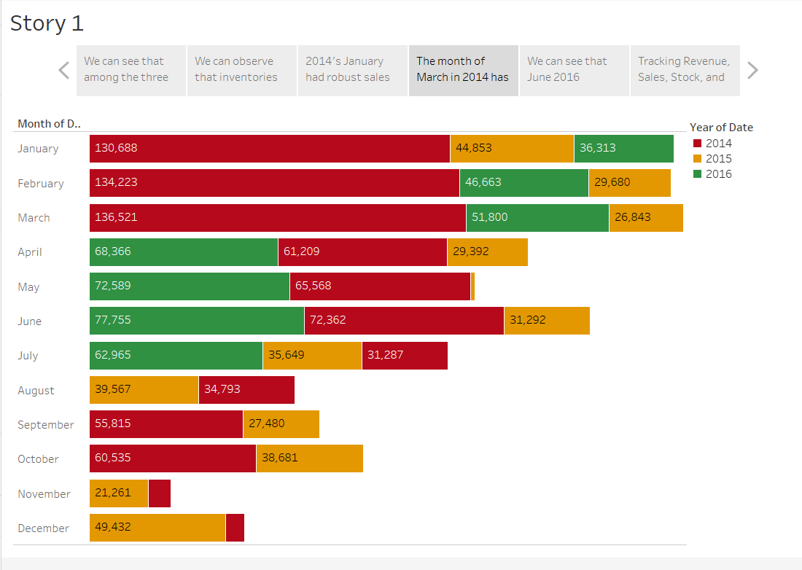

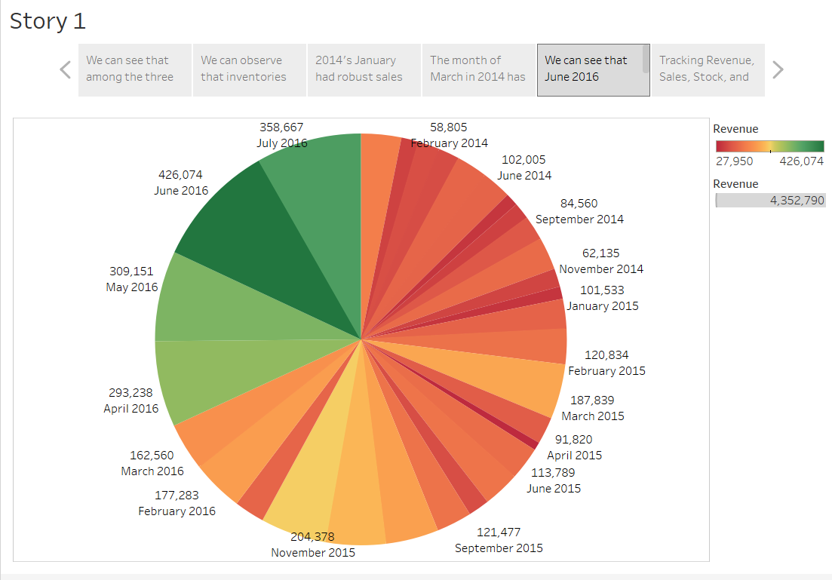

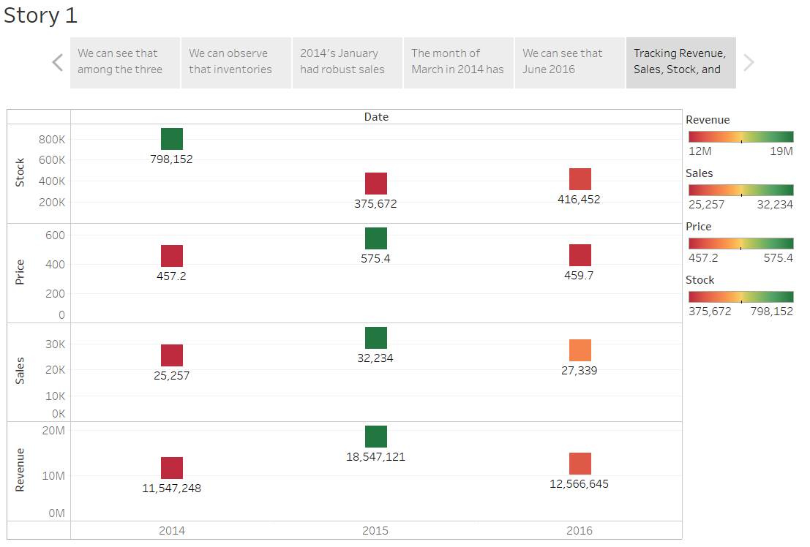

### Performance Testing

Performance testing for Tableau focuses on evaluating the software's speed, responsiveness, and scalability under various conditions and workloads. It involves measuring and analysing key performance indicators such as query response time, data loading speed, dashboard rendering time, and concurrent user handling capacity. The testing process helps identify any performance bottlenecks, optimize system configurations, and ensure that Tableau can handle the expected workload efficiently, providing users with a smooth and responsive experience while working with large datasets and complex visualizations.

### Web Integration

Publishing helps us track and monitor key performance metrics, to communicate results and progress. Help a publisher stay informed, make better decisions, and communicate their performance to others.

Integrating dashboard/reports/stories to web

Step 1: Go to Dashboard/story/report, click on share button on the top ribbon

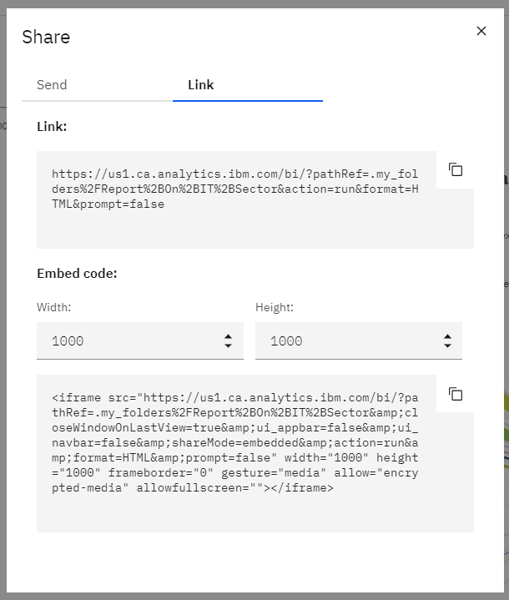

**Note:**You can also change the width and height of the dashboard/story/report as you like.

**Activity 1: Integrating with Tableau Public**

**Explanatory videos**

<https://drive.google.com/file/d/1sSkBsl9GLGZPjl2WVSPMKVYzmiW2igLn/view?usp=sharing>

<https://drive.google.com/file/d/1ww10m6JPNayqog2ivRmQn-YnqgqCl-qW/view?usp=sharing>

**Activity 2: Integrating with bootstrap website**

**Explanatory video:**

[**https://drive.google.com/file/d/1BVDM0eY6jRye54eGF-1uBX5blTGDPe0O/view?usp=sharing**](https://drive.google.com/file/d/1BVDM0eY6jRye54eGF-1uBX5blTGDPe0O/view?usp=sharing)

**Activity 3: Implementing Flask**

**Explanatory video:**

<https://drive.google.com/file/d/1zaaUqZxNQoaWS6ZbjgQZxPBCW1SNHXTv/view?usp=sharing>

**Appendix**

**Source Code:**

<!DOCTYPE html>

<html lang="en">

<head>

  <meta charset="utf-8">

  <meta content="width=device-width, initial-scale=1.0" name="viewport">

  <title>StockSense</title>

  <meta content="" name="description">

  <meta content="" name="keywords">

  <!-- Favicons -->

  <link href="assets/img/favicon.png" rel="icon">

  <link href="assets/img/apple-touch-icon.png" rel="apple-touch-icon">

  <!-- Google Fonts -->

  <link href="https://fonts.googleapis.com/css?family=Open+Sans:300,300i,400,400i,600,600i,700,700i|Roboto:300,300i,400,400i,500,500i,600,600i,700,700i|Poppins:300,300i,400,400i,500,500i,600,600i,700,700i" rel="stylesheet">

  <!-- Vendor CSS Files -->

  <link href="assets/vendor/aos/aos.css" rel="stylesheet">

  <link href="assets/vendor/bootstrap/css/bootstrap.min.css" rel="stylesheet">

  <link href="assets/vendor/bootstrap-icons/bootstrap-icons.css" rel="stylesheet">

  <link href="assets/vendor/boxicons/css/boxicons.min.css" rel="stylesheet">

  <link href="assets/vendor/glightbox/css/glightbox.min.css" rel="stylesheet">

  <link href="assets/vendor/swiper/swiper-bundle.min.css" rel="stylesheet">

  <!-- Template Main CSS File -->

  <link href="assets/css/style.css" rel="stylesheet">

  <!-- =======================================================

  * Template Name: Techie

  * Updated: May 30 2023 with Bootstrap v5.3.0

  * Template URL: https://bootstrapmade.com/techie-free-skin-bootstrap-3/

  * Author: BootstrapMade.com

  * License: https://bootstrapmade.com/license/

  ======================================================== -->

</head>

<body>

  <!-- ======= Header ======= -->

  <header id="header" class="fixed-top ">

    <div class="container d-flex align-items-center justify-content-between">

      <h1 class="logo"><a href="index.html">StockSense</a></h1>

      <!-- Uncomment below if you prefer to use an image logo -->

      <!-- <a href="index.html" class="logo"><img src="assets/img/logo.png" alt="" class="img-fluid"></a>-->

      <nav id="navbar" class="navbar">

        <ul>

          <li><a class="nav-link scrollto active" href="#hero">Home</a></li>

          <li><a class="nav-link scrollto" href="#about">About</a></li>

          <li><a class="nav-link scrollto" href="#services">Dashboard</a></li>

          <li><a class="nav-link scrollto " href="#Story">Story</a></li>

          <li><a class="nav-link scrollto" href="#team">Team</a></li>

          <!-- <li class="dropdown"><a href="#"><span>Drop Down</span> <i class="bi bi-chevron-down"></i></a>

            <ul>

              <li><a href="#">Drop Down 1</a></li>

              <li class="dropdown"><a href="#"><span>Deep Drop Down</span> <i class="bi bi-chevron-right"></i></a>

                <ul>

                  <li><a href="#">Deep Drop Down 1</a></li>

                  <li><a href="#">Deep Drop Down 2</a></li>

                  <li><a href="#">Deep Drop Down 3</a></li>

                  <li><a href="#">Deep Drop Down 4</a></li>

                  <li><a href="#">Deep Drop Down 5</a></li>

                </ul>

              </li>

              <li><a href="#">Drop Down 2</a></li>

              <li><a href="#">Drop Down 3</a></li>

              <li><a href="#">Drop Down 4</a></li>

            </ul>

          </li> -->

          <li><a class="nav-link scrollto" href="#contact">Contact</a></li>

          <li><a class="getstarted scrollto" href="#about">Get Started</a></li>

        </ul>

        <i class="bi bi-list mobile-nav-toggle"></i>

      </nav><!-- .navbar -->

    </div>

  </header><!-- End Header -->

  <!-- ======= Hero Section ======= -->

  <section id="hero" class="d-flex align-items-center">

    <div class="container-fluid" data-aos="fade-up">

      <div class="row justify-content-center">

        <div class="col-xl-5 col-lg-6 pt-3 pt-lg-0 order-2 order-lg-1 d-flex flex-column justify-content-center">

          <h1>Retail Store Stock Inventory Analysis</h1>

          <h2>We are team of talented analyser making Analysis for retail store stockes</h2>

          <div><a href="#about" class="btn-get-started scrollto">Get Started</a></div>

        </div>

        <div class="col-xl-4 col-lg-6 order-1 order-lg-2 hero-img" data-aos="zoom-in" data-aos-delay="150">

          <img src="assets/img/hero-img.png" class="img-fluid animated" alt="">

        </div>

      </div>

    </div>

  </section><!-- End Hero -->

  <main id="main">

    <!-- ======= About Section ======= -->

    <section id="about" class="about">

      <div class="container">

        <div class="row">

          <div class="col-lg-6 order-1 order-lg-2" data-aos="zoom-in" data-aos-delay="150">

            <img src="assets/img/about.jpg" class="img-fluid" alt="">

          </div>

          <div class="col-lg-6 pt-4 pt-lg-0 order-2 order-lg-1 content" data-aos="fade-right">

            <h3>Unveiling the Power of Data</h3>

            <p class="fst-italic">

              <h5>Retail Store Stock Inventory Analysis for Efficient Operations and Enhanced Profitability</h5>

            </p>

            <ul>

              <li><i class="bi bi-check-circle"></i> Demand forecasting: Retail store stock inventory analysis involves analyzing historical sales data, market trends, and customer behavior to accurately forecast demand for different products. By understanding demand patterns, retailers can optimize their inventory levels, ensuring they have sufficient stock to meet customer demand without excessive overstocking.</li>

              <li><i class="bi bi-check-circle"></i>Inventory optimization: Analyzing stock inventory data helps retailers identify slow-moving or obsolete items, enabling them to make informed decisions on markdowns, promotions, or liquidation strategies. It also allows them to identify popular products and allocate appropriate space and resources to maximize sales potential.</li>

              <li><i class="bi bi-check-circle"></i> Replenishment planning: Effective inventory analysis enables retailers to determine optimal reorder points and reorder quantities for different products. By considering lead times, demand variability, and desired service levels, retailers can streamline their replenishment processes, minimize stockouts, and avoid unnecessary inventory holding costs.</li>

            </ul>

            <a href="#" class="read-more">Read More <i class="bi bi-long-arrow-right"></i></a>

          </div>

        </div>

      </div>

    </section><!-- End About Section -->

    <!-- ======= Counts Section ======= -->

    <section id="counts" class="counts">

      <div class="container">

        <div class="row counters">

          <div class="col-lg-3 col-6 text-center">

            <span data-purecounter-start="0" data-purecounter-end="232" data-purecounter-duration="1" class="purecounter"></span>

            <p>Clients</p>

          </div>

          <div class="col-lg-3 col-6 text-center">

            <span data-purecounter-start="0" data-purecounter-end="521" data-purecounter-duration="1" class="purecounter"></span>

            <p>Projects</p>

          </div>

          <div class="col-lg-3 col-6 text-center">

            <span data-purecounter-start="0" data-purecounter-end="1463" data-purecounter-duration="1" class="purecounter"></span>

            <p>Hours Of Support</p>

          </div>

          <div class="col-lg-3 col-6 text-center">

            <span data-purecounter-start="0" data-purecounter-end="15" data-purecounter-duration="1" class="purecounter"></span>

            <p>Hard Workers</p>

          </div>

        </div>

      </div>

    </section><!-- End Counts Section -->

    <section id="Dashboard" class="Dashboard section-bg">

      <div class="container" data-aos="fade-up">

        <div class="section-title">

          <h2>Dashboard</h2>

    <div class='tableauPlaceholder' id='viz1688106870057' style='position: relative'><noscript><a href='#'><img alt='Dashboard 1 ' src='https:&#47;&#47;public.tableau.com&#47;static&#47;images&#47;Fi&#47;Final_DA_Projectstock&#47;Dashboard1&#47;1_rss.png' style='border: none' /></a></noscript><object class='tableauViz'  style='display:none;'><param name='host_url' value='https%3A%2F%2Fpublic.tableau.com%2F' /> <param name='embed_code_version' value='3' /> <param name='site_root' value='' /><param name='name' value='Final_DA_Projectstock&#47;Dashboard1' /><param name='tabs' value='no' /><param name='toolbar' value='yes' /><param name='static_image' value='https:&#47;&#47;public.tableau.com&#47;static&#47;images&#47;Fi&#47;Final_DA_Projectstock&#47;Dashboard1&#47;1.png' /> <param name='animate_transition' value='yes' /><param name='display_static_image' value='yes' /><param name='display_spinner' value='yes' /><param name='display_overlay' value='yes' /><param name='display_count' value='yes' /><param name='language' value='en-US' /></object></div>                <script type='text/javascript'>                    var divElement = document.getElementById('viz1688106870057');                    var vizElement = divElement.getElementsByTagName('object')[0];                    if ( divElement.offsetWidth > 800 ) { vizElement.style.width='1700px';vizElement.style.height='1027px';} else if ( divElement.offsetWidth > 500 ) { vizElement.style.width='1700px';vizElement.style.height='1027px';} else { vizElement.style.width='100%';vizElement.style.height='2027px';}                     var scriptElement = document.createElement('script');                    scriptElement.src = 'https://public.tableau.com/javascripts/api/viz_v1.js';                    vizElement.parentNode.insertBefore(scriptElement, vizElement);                </script>

    <!-- ======= Services Section ======= -->

    <section id="services" class="services section-bg">

      <div class="container" data-aos="fade-up">

        <div class="section-title">

          <h2>Services</h2>

          <p>One of the key services offered in retail store stock inventory analysis is demand forecasting, which helps retailers accurately predict future demand for products and optimize their inventory levels accordingly.</p>

        </div>

        <div class="row gy-4">

          <div class="col-lg-4 col-md-6 d-flex align-items-stretch" data-aos="zoom-in" data-aos-delay="100">

            <div class="icon-box iconbox-blue">

              <div class="icon">

                <svg width="100" height="100" viewBox="0 0 600 600" xmlns="http://www.w3.org/2000/svg">

                  <path stroke="none" stroke-width="0" fill="#f5f5f5" d="M300,521.0016835830174C376.1290562159157,517.8887921683347,466.0731472004068,529.7835943286574,510.70327084640275,468.03025145048787C554.3714126377745,407.6079735673963,508.03601936045806,328.9844924480964,491.2728898941984,256.3432110539036C474.5976632858925,184.082847569629,479.9380746630129,96.60480741107993,416.23090153303,58.64404602377083C348.86323505073057,18.502131276798302,261.93793281208167,40.57373210992963,193.5410806939664,78.93577620505333C130.42746243093433,114.334589627462,98.30271207620316,179.96522072025542,76.75703585869454,249.04625023123273C51.97151888228291,328.5150500222984,13.704378332031375,421.85034740162234,66.52175969318436,486.19268352777647C119.04800174914682,550.1803526380478,217.28368757567262,524.383925680826,300,521.0016835830174"></path>

                </svg>

                <i class="bx bxl-dribbble"></i>

              </div>

              <h4><a href="">Replenishment planning </a></h4>

              <p>Retail store stock inventory analysis services can provide replenishment planning services to optimize the process of restocking inventory.</p>

            </div>

          </div>

          <div class="col-lg-4 col-md-6 d-flex align-items-stretch" data-aos="zoom-in" data-aos-delay="200">

            <div class="icon-box iconbox-orange ">

              <div class="icon">

                <svg width="100" height="100" viewBox="0 0 600 600" xmlns="http://www.w3.org/2000/svg">

                  <path stroke="none" stroke-width="0" fill="#f5f5f5" d="M300,582.0697525312426C382.5290701553225,586.8405444964366,449.9789794690241,525.3245884688669,502.5850820975895,461.55621195738473C556.606425686781,396.0723002908107,615.8543463187945,314.28637112970534,586.6730223649479,234.56875336149918C558.9533121215079,158.8439757836574,454.9685369536778,164.00468322053177,381.49747125262974,130.76875717737553C312.15926192815925,99.40240125094834,248.97055460311594,18.661163978235184,179.8680185752513,50.54337015887873C110.5421016452524,82.52863877960104,119.82277516462835,180.83849132639028,109.12597500060166,256.43424936330496C100.08760227029461,320.3096726198365,92.17705696193138,384.0621239912766,124.79988738764834,439.7174275375508C164.83382741302287,508.01625554203684,220.96474134820875,577.5009287672846,300,582.0697525312426"></path>

                </svg>

                <i class="bx bx-file"></i>

              </div>

              <h4><a href=""></a>Inventory optimization</h4>

              <p>Optimize inventory levels through analyzing sales data, forecasting demand, identifying slow-moving items, and determining optimal reorder points. </p>

            </div>

          </div>

          <div class="col-lg-4 col-md-6 d-flex align-items-stretch" data-aos="zoom-in" data-aos-delay="300">

            <div class="icon-box iconbox-pink">

              <div class="icon">

                <svg width="100" height="100" viewBox="0 0 600 600" xmlns="http://www.w3.org/2000/svg">

                  <path stroke="none" stroke-width="0" fill="#f5f5f5" d="M300,541.5067337569781C382.14930387511276,545.0595476570109,479.8736841581634,548.3450877840088,526.4010558755058,480.5488172755941C571.5218469581645,414.80211281144784,517.5187510058486,332.0715597781072,496.52539010469104,255.14436215662573C477.37192572678356,184.95920475031193,473.57363656557914,105.61284051026155,413.0603344069578,65.22779650032875C343.27470386102294,18.654635553484475,251.2091493199835,5.337323636656869,175.0934190732945,40.62881213300186C97.87086631185822,76.43348514350839,51.98124368387456,156.15599469081315,36.44837278890362,239.84606092416172C21.716077023791087,319.22268207091537,43.775223500013084,401.1760424656574,96.891909868211,461.97329694683043C147.22146801428983,519.5804099606455,223.5754009179313,538.201503339737,300,541.5067337569781"></path>

                </svg>

                <i class="bx bx-tachometer"></i>

              </div>

              <h4><a href="">Performance measurement </a></h4>

              <p>Retailers can benefit from performance measurement services offered by retail store stock inventory analysis</p>

            </div>

          </div>

          <div class="col-lg-4 col-md-6 d-flex align-items-stretch" data-aos="zoom-in" data-aos-delay="100">

            <div class="icon-box iconbox-yellow">

              <div class="icon">

                <svg width="100" height="100" viewBox="0 0 600 600" xmlns="http://www.w3.org/2000/svg">

                  <path stroke="none" stroke-width="0" fill="#f5f5f5" d="M300,503.46388370962813C374.79870501325706,506.71871716319447,464.8034551963731,527.1746412648533,510.4981551193396,467.86667711651364C555.9287308511215,408.9015244558933,512.6030010748507,327.5744911775523,490.211057578863,256.5855673507754C471.097692560561,195.9906835881958,447.69079081568157,138.11976852964426,395.19560036434837,102.3242989838813C329.3053358748298,57.3949838291264,248.02791733380457,8.279543830951368,175.87071277845988,42.242879143198664C103.41431057327972,76.34704239035025,93.79494320519305,170.9812938413882,81.28167332365135,250.07896920659033C70.17666984294237,320.27484674793965,64.84698225790005,396.69656628748305,111.28512138212992,450.4950937839243C156.20124167950087,502.5303643271138,231.32542653798444,500.4755392045468,300,503.46388370962813"></path>

                </svg>

                <i class="bx bx-layer"></i>

              </div>

              <h4><a href="">Demand forecasting</a></h4>

              <p>Accurate demand forecasting is crucial for retailers to make informed decisions about inventory management</p>

            </div>

          </div>

          <div class="col-lg-4 col-md-6 d-flex align-items-stretch" data-aos="zoom-in" data-aos-delay="200">

            <div class="icon-box iconbox-red">

              <div class="icon">

                <svg width="100" height="100" viewBox="0 0 600 600" xmlns="http://www.w3.org/2000/svg">

                  <path stroke="none" stroke-width="0" fill="#f5f5f5" d="M300,532.3542879108572C369.38199826031484,532.3153073249985,429.10787420159085,491.63046689027357,474.5244479745417,439.17860296908856C522.8885846962883,383.3225815378663,569.1668002868075,314.3205725914397,550.7432151929288,242.7694973846089C532.6665558377875,172.5657663291529,456.2379748765914,142.6223662098291,390.3689995646985,112.34683881706744C326.66090330228417,83.06452184765237,258.84405631176094,53.51806209861945,193.32584062364296,78.48882559362697C121.61183558270385,105.82097193414197,62.805066853699245,167.19869350419734,48.57481801355237,242.6138429142374C34.843463184063346,315.3850353017275,76.69343916112496,383.4422959591041,125.22947124332185,439.3748458443577C170.7312796277747,491.8107796887764,230.57421082200815,532.3932930995766,300,532.3542879108572"></path>

                </svg>

                <i class="bx bx-slideshow"></i>

              </div>

              <h4><a href="">Data-driven insights and reporting</a></h4>

              <p>Retail store stock inventory analysis can generate data-driven insights and provide comprehensive reports to retailers</p>

            </div>

          </div>

          <div class="col-lg-4 col-md-6 d-flex align-items-stretch" data-aos="zoom-in" data-aos-delay="300">

            <div class="icon-box iconbox-teal">

              <div class="icon">

                <svg width="100" height="100" viewBox="0 0 600 600" xmlns="http://www.w3.org/2000/svg">

                  <path stroke="none" stroke-width="0" fill="#f5f5f5" d="M300,566.797414625762C385.7384707136149,576.1784315230908,478.7894351017131,552.8928747891023,531.9192734346935,484.94944893311C584.6109503024035,417.5663521118492,582.489472248146,322.67544863468447,553.9536738515405,242.03673114598146C529.1557734026468,171.96086150256528,465.24506316201064,127.66468636344209,395.9583748389544,100.7403814666027C334.2173773831606,76.7482773500951,269.4350130405921,84.62216499799875,207.1952322260088,107.2889140133804C132.92018162631612,134.33871894543012,41.79353780512637,160.00259165414826,22.644507872594943,236.69541883565114C3.319112789854554,314.0945973066697,72.72355303640163,379.243833228382,124.04198916343866,440.3218312028393C172.9286146004772,498.5055451809895,224.45579914871206,558.5317968840102,300,566.797414625762"></path>

                </svg>

                <i class="bx bx-arch"></i>

              </div>

              <h4><a href="">Inventory auditing and reconciliation</a></h4>

              <p>Retail store stock inventory analysis services can also provide inventory auditing and reconciliation services</p>

            </div>

          </div>

        </div>

      </div>

    </section><!-- End Services Section -->

    <!-- ======= Features Section ======= -->

    <section id="features" class="features">

      <div class="container" data-aos="fade-up">

        <div class="section-title">

          <h2>Features</h2>

          <p>Empowering Retailers with Actionable Insights: Key Features of Retail Store Stock Inventory Analysis</p>

        </div>

        <div class="row">

          <div class="col-lg-6 order-2 order-lg-1 d-flex flex-column align-items-lg-center">

            <div class="icon-box mt-5 mt-lg-0" data-aos="fade-up" data-aos-delay="100">

              <i class="bx bx-receipt"></i>

              <h4>Inventory visibility</h4>

              <p>The analysis provides a clear and comprehensive view of the available stock across different locations, allowing retailers to track inventory levels in real-time.</p>

            </div>

            <div class="icon-box mt-5" data-aos="fade-up" data-aos-delay="200">

              <i class="bx bx-cube-alt"></i>

              <h4>Cost Analysis</h4>

              <p>Inventory analysis enables retailers to assess the cost components associated with inventory management, including carrying costs, holding costs, and order costs.</p>

            </div>

            <div class="icon-box mt-5" data-aos="fade-up" data-aos-delay="300">

              <i class="bx bx-images"></i>

              <h4>Supplier performance analysis</h4>

              <p>By analyzing inventory data, retailers can evaluate the performance of their suppliers in terms of delivery times, order accuracy, and product quality. </p>

            </div>

            <div class="icon-box mt-5" data-aos="fade-up" data-aos-delay="400">

              <i class="bx bx-shield"></i>

            <h4>Upgrade</h4>

              <p>These features collectively empower retailers to make data-driven decisions, optimize inventory levels, reduce costs, and enhance customer satisfaction.</p>

            </div>

          </div>

          <div class="image col-lg-6 order-1 order-lg-2 " data-aos="zoom-in" data-aos-delay="100">

            <img src="assets/img/features.svg" alt="" class="img-fluid">

          </div>

        </div>

      </div>

    </section><!-- End Features Section -->

    <!-- ======= Story Section ======= -->

    <section id="Story" class="Story">

      <div class="container" data-aos="fade-up">

        <div class="section-title">

          <h2>STORY</h2>

          <p>In this captivating story brought to life through Tableau, we embark on an immersive journey into the realm of retail store stock inventory analysis. With rich visuals and interactive dashboards, we delve into the intricate world of inventory management and uncover valuable insights that drive efficiency and profitability.</p>

        </div>

        <div class='tableauPlaceholder' id='viz1688106962593' style='position: relative'><noscript><a href='#'><img alt='Story 1 ' src='https:&#47;&#47;public.tableau.com&#47;static&#47;images&#47;Fi&#47;Final_DA_Projectstockstory&#47;Story1&#47;1_rss.png' style='border: none' /></a></noscript><object class='tableauViz'  style='display:none;'><param name='host_url' value='https%3A%2F%2Fpublic.tableau.com%2F' /> <param name='embed_code_version' value='3' /> <param name='site_root' value='' /><param name='name' value='Final_DA_Projectstockstory&#47;Story1' /><param name='tabs' value='no' /><param name='toolbar' value='yes' /><param name='static_image' value='https:&#47;&#47;public.tableau.com&#47;static&#47;images&#47;Fi&#47;Final_DA_Projectstockstory&#47;Story1&#47;1.png' /> <param name='animate_transition' value='yes' /><param name='display_static_image' value='yes' /><param name='display_spinner' value='yes' /><param name='display_overlay' value='yes' /><param name='display_count' value='yes' /><param name='language' value='en-US' /></object></div>                <script type='text/javascript'>                    var divElement = document.getElementById('viz1688106962593');                    var vizElement = divElement.getElementsByTagName('object')[0];                    vizElement.style.width='1016px';vizElement.style.height='991px';                    var scriptElement = document.createElement('script');                    scriptElement.src = 'https://public.tableau.com/javascripts/api/viz_v1.js';                    vizElement.parentNode.insertBefore(scriptElement, vizElement);                </script>

  </div>

      </section>

    </section><!-- End Portfolio Section -->

    <!-- ======= Our Team Section ======= -->

    <section id="team" class="team">

      <div class="container" data-aos="fade-up">

       <!--  Section Title -->

      <div class="container section-title" data-aos="fade-up">

        <h2>OUR TEAM MEMBERS</h2>

      </div><!-- End Section Title -->

      <div class="container">

        <div class="row gy-5">

          <div class="col-lg-4 col-md-6 member" data-aos="fade-up" data-aos-delay="100">

            <div class="member-img">

              <img src="assets/img/team-1.jpg" class="img-fluid" alt="">

              <div class="social">

                <a href="https://twitter.com/Chandureddy9502?t=GLZJuSc4M6WaGkGIgHj5BA&s=08"><i class="bi bi-twitter"></i></a>

                <a href="https://www.facebook.com/profile.php?id=100022360232561&mibextid=ZbWKwL"><i class="bi bi-facebook"></i></a>

                <a href="https://instagram.com/_mouli_reddy___?igshid=MzNlNGNkZWQ4Mg=="><i class="bi bi-instagram"></i></a>

                <a href="https://www.linkedin.com/in/sirivella-madhan-chandra-mouli-reddy-99a524250"><i class="bi bi-linkedin"></i></a>

              </div>

            </div>

            <div class="member-info text-center">

              <h4>Chandramouli Reddy</h4>

            </div>

          </div><!-- End Team Member -->

          <div class="col-lg-4 col-md-6 member" data-aos="fade-up" data-aos-delay="200">

            <div class="member-img">

              <img src="assets/img/team-2.jpg" class="img-fluid" alt="">

              <div class="social">

                <a href="https://twitter.com/Hemanth_shaiva_?t=gn5j_0uZ3M49r9KeoQOBpA&s=08" target="_blank"><i class="bi bi-twitter"></i></a>

                <a href="https://instagram.com/hemanth_shaiva_?igshid=MzNlNGNkZWQ4Mg=="><i class="bi bi-instagram"></i></a>

                <a href="https://www.linkedin.com/in/hemanth-a-r-8a5231249"><i class="bi bi-linkedin"></i></a>

              </div>

            </div>

            <div class="member-info text-center">

              <h4>Hemanth A R</h4>

            </div>

          </div><!-- End Team Member -->

          <div class="col-lg-4 col-md-6 member" data-aos="fade-up" data-aos-delay="300">

            <div class="member-img">

              <img src="assets/img/team-3.jpg" class="img-fluid" alt="">

              <div class="social">

                <a href="https://instagram.com/chakradhar_rao2?igshid=MjEwN2IyYWYwYw=="><i class="bi bi-instagram"></i></a>

              </div>

            </div>

            <div class="member-info text-center">

              <h4>Chakradar Rao</h4>

            </div>

          </div><!-- End Team Member -->

          <div class="col-lg-4 col-md-6 member" data-aos="fade-up" data-aos-delay="400">

            <div class="member-img">

              <img src="assets/img/team-4.jpg" class="img-fluid" alt="">

              <div class="social">

                <a href="https://instagram.com/krishnasuhas__?igshid=MzNlNGNkZWQ4Mg=="><i class="bi bi-instagram"></i></a>

              </div>

            </div>

            <div class="member-info text-center">

              <h4> Krishna Suhas</h4>

            </div>

          </div><!-- End Team Member -->

          <!-- End Team Member -->

<!-- End Team Member -->

        </div>

      </div>

    </section><!-- End Our Team Section -->

    <!-- ======= Frequently Asked Questions Section ======= -->

    <section id="faq" class="faq">

      <div class="container" data-aos="fade-up">

        <div class="section-title">

          <h2>Frequently Asked Questions</h2>

          <!-- <p>Magnam dolores commodi suscipit. Necessitatibus eius consequatur ex aliquid fuga eum quidem. Sit sint consectetur velit. Quisquam quos quisquam cupiditate. Et nemo qui impedit suscipit alias ea. Quia fugiat sit in iste officiis commodi quidem hic quas.</p> -->

        </div>

        <div class="faq-list">

          <ul>

            <li data-aos="fade-up" data-aos="fade-up" data-aos-delay="100">

              <i class="bx bx-help-circle icon-help"></i> <a data-bs-toggle="collapse" class="collapse" data-bs-target="#faq-list-1">1.How can I analyze the current stock levels for different products in our retail stores? <i class="bx bx-chevron-down icon-show"></i><i class="bx bx-chevron-up icon-close"></i></a>

              <div id="faq-list-1" class="collapse show" data-bs-parent=".faq-list">

                <p>

                  In the Tableau dashboard, you can navigate to the "Stock Levels" section. There, you will find interactive visualizations that allow you to explore the stock levels of various products in different store locations. You can filter by product category, store, or specific time periods to gain a comprehensive understanding of current stock levels.                </p>

              </div>

            </li>

            <li data-aos="fade-up" data-aos-delay="200">

              <i class="bx bx-help-circle icon-help"></i> <a data-bs-toggle="collapse" data-bs-target="#faq-list-2" class="collapsed">2. Can I view the inventory turnover rate and identify slow-moving or fast-selling products? <i class="bx bx-chevron-down icon-show"></i><i class="bx bx-chevron-up icon-close"></i></a>

              <div id="faq-list-2" class="collapse" data-bs-parent=".faq-list">

                <p>

                  Absolutely! The "Inventory Turnover" dashboard provides insights into the turnover rate of products. It highlights slow-moving and fast-selling items, allowing you to identify potential inventory management issues. You can drill down into specific products to analyze their individual turnover rates and make informed decisions regarding restocking or clearance strategies.                </p>

              </div>

            </li>

            <li data-aos="fade-up" data-aos-delay="300">

              <i class="bx bx-help-circle icon-help"></i> <a data-bs-toggle="collapse" data-bs-target="#faq-list-3" class="collapsed">3. How can we track stock shortages or overstocks in real-time and receive alerts?<i class="bx bx-chevron-down icon-show"></i><i class="bx bx-chevron-up icon-close"></i></a>

              <div id="faq-list-3" class="collapse" data-bs-parent=".faq-list">

                <p>

                  We have implemented a real-time monitoring system that tracks stock levels continuously. In the Tableau dashboard, the "Stock Alerts" section displays a summary of any stock shortages or overstocks. You can set up automated alerts to notify relevant team members via email or push notifications when inventory levels reach critical thresholds.                </p>

              </div>

            </li>

            <li data-aos="fade-up" data-aos-delay="400">

              <i class="bx bx-help-circle icon-help"></i> <a data-bs-toggle="collapse" data-bs-target="#faq-list-4" class="collapsed">4. Can we visualize the stock distribution across different store locations or regions? <i class="bx bx-chevron-down icon-show"></i><i class="bx bx-chevron-up icon-close"></i></a>

              <div id="faq-list-4" class="collapse" data-bs-parent=".faq-list">

                <p>

                  Yes, you can explore the stock distribution across store locations or regions using the "Store Analysis" dashboard. It presents interactive maps and charts that illustrate the quantity of stock available at each location. You can filter by time period or specific products to gain insights into regional stock distribution and identify any imbalances or inefficiencies.                </p>

              </div>

            </li>

            <li data-aos="fade-up" data-aos-delay="500">

              <i class="bx bx-help-circle icon-help"></i> <a data-bs-toggle="collapse" data-bs-target="#faq-list-5" class="collapsed">5. How can we identify product trends and analyze their impact on inventory management? <i class="bx bx-chevron-down icon-show"></i><i class="bx bx-chevron-up icon-close"></i></a>

              <div id="faq-list-5" class="collapse" data-bs-parent=".faq-list">

                <p>

                  The "Product Trends" dashboard enables you to analyze product trends over time. It displays visualizations that highlight sales performance, seasonality patterns, and overall demand for specific products. By understanding these trends, you can optimize inventory management strategies, forecast future demand, and avoid stockouts or overstock situations.                </p>

              </div>

            </li>

          </ul>

        </div>

      </div>

    </section><!-- End Frequently Asked Questions Section -->

    <!-- ======= Contact Section ======= -->

    <section id="contact" class="contact section-bg">

      <div class="container" data-aos="fade-up">

        <div class="section-title">

          <h2>Contact</h2>

          <!-- <p>Magnam dolores commodi suscipit. Necessitatibus eius consequatur ex aliquid fuga eum quidem. Sit sint consectetur velit. Quisquam quos quisquam cupiditate. Et nemo qui impedit suscipit alias ea. Quia fugiat sit in iste officiis commodi quidem hic quas.</p> -->

        </div>

        <div class="row">

          <div class="col-lg-6">

            <div class="info-box mb-4">

              <i class="bx bx-map"></i>

              <h3>Our Address</h3>

              <p>VIT-AP University, G-30, Inavolu, Beside AP Secretariat Amaravati, Andhra Pradesh 522237, India</p>

            </div>

          </div>

          <div class="col-lg-3 col-md-6">

            <div class="info-box  mb-4">

              <i class="bx bx-envelope"></i>

              <h3>Email Us</h3>

             <p> <a href="hemanthar2249@gmail.com">hemanthar2249@gmail.com </a></p>

            </div>

          </div>

          <div class="col-lg-3 col-md-6">

            <div class="info-box  mb-4">

              <i class="bx bx-phone-call"></i>

              <h3>Call Us</h3>

              <p>8073122149 <br> 7396695444 <br> 8374370051 <br> 6281532078</p>

            </div>

          </div>

        </div>

        <div class="row">

          <div class="col-lg-6 ">

            <iframe src="https://www.google.com/maps/embed?pb=!1m18!1m12!1m3!1d3825.5901542627444!2d80.49809267480853!3d16.49627768424684!2m3!1f0!2f0!3f0!3m2!1i1024!2i768!4f13.1!3m3!1m2!1s0x3a35f27d40f21c55%3A0x1490eacd54859850!2sVIT-AP%20University!5e0!3m2!1sen!2sin!4v1688077167954!5m2!1sen!2sin" width="600" height="450" style="border:0;" allowfullscreen="" loading="lazy" referrerpolicy="no-referrer-when-downgrade"></iframe>          </div>

          <div class="col-lg-6">

            <form action="forms/contact.php" method="post" role="form" class="php-email-form">

              <div class="row">

                <div class="col-md-6 form-group">

                  <input type="text" name="name" class="form-control" id="name" placeholder="Your Name" required>

                </div>

                <div class="col-md-6 form-group mt-3 mt-md-0">

                  <input type="email" class="form-control" name="email" id="email" placeholder="Your Email" required>

                </div>

              </div>

              <div class="form-group mt-3">

                <input type="text" class="form-control" name="subject" id="subject" placeholder="Subject" required>

              </div>

              <div class="form-group mt-3">

                <textarea class="form-control" name="message" rows="5" placeholder="Message" required></textarea>

              </div>

              <div class="my-3">

                <div class="loading">Loading</div>

                <div class="error-message"></div>

                <div class="sent-message">Your message has been sent. Thank you!</div>

              </div>

              <div class="text-center"><button type="submit">Send Message</button></div>

            </form>

          </div>

        </div>

      </div>

    </section><!-- End Contact Section -->

  </main><!-- End #main -->

  <!-- ======= Footer ======= -->

  <footer id="footer">

    <div class="footer-top">

      <div class="container">

        <div class="row">

          <div class="col-lg-3 col-md-6 footer-contact">

            <h3>StockSense</h3>

            <p>

              VIT-AP University <br>

              G-30, Inavolu, Beside AP Secretariat <br>

              Amaravati, Andhra Pradesh <br><br>

              <strong>Phone:</strong> 8073122149 <br> 7396695444 <br> 8374370051 <br> 6281532078<br>

              <strong>Email:</strong> info@example.com<br>

            </p>

          </div>

          <div class="col-lg-2 col-md-6 footer-links">

            <h4>Useful Links</h4>

            <ul>

              <li><i class="bx bx-chevron-right"></i> <a href="#">Home</a></li>

              <li><i class="bx bx-chevron-right"></i> <a href="#">About us</a></li>

              <li><i class="bx bx-chevron-right"></i> <a href="#">Services</a></li>

              <li><i class="bx bx-chevron-right"></i> <a href="#">Terms of service</a></li>

              <li><i class="bx bx-chevron-right"></i> <a href="#">Privacy policy</a></li>

            </ul>

          </div>

          <div class="col-lg-4 col-md-6 footer-newsletter">

            <h4>Join Our Newsletter</h4>

            <p>Stay informed and never miss an update - join our newsletter today!</p>

            <form action="" method="post">

              <input type="email" name="email"><input type="submit" value="Subscribe">

            </form>

          </div>

        </div>

      </div>

    </div>

    <div class="container">

      <div class="copyright-wrap d-md-flex py-4">

        <div class="me-md-auto text-center text-md-start">

          <div class="copyright">

            &copy; Copyright <strong><span>StockSense</span></strong>. All Rights Reserved

          </div>

          <div class="credits">

            <!-- All the links in the footer should remain intact. -->

            <!-- You can delete the links only if you purchased the pro version. -->

            <!-- Licensing information: https://bootstrapmade.com/license/ -->

            <!-- Purchase the pro version with working PHP/AJAX contact form: https://bootstrapmade.com/techie-free-skin-bootstrap-3/ -->

            Designed by <a href="https://bootstrapmade.com/">BootstrapMade</a>

          </div>

        </div>

        <div class="social-links text-center text-md-right pt-3 pt-md-0">

          <a href="#" class="twitter"><i class="bx bxl-twitter"></i></a>

          <a href="#" class="facebook"><i class="bx bxl-facebook"></i></a>

          <a href="#" class="instagram"><i class="bx bxl-instagram"></i></a>

          <a href="#" class="google-plus"><i class="bx bxl-skype"></i></a>

          <a href="#" class="linkedin"><i class="bx bxl-linkedin"></i></a>

        </div>

      </div>

    </div>

  </footer><!-- End Footer -->

  <a href="#" class="back-to-top d-flex align-items-center justify-content-center"><i class="bi bi-arrow-up-short"></i></a>

  <div id="preloader"></div>

  <!-- Vendor JS Files -->

  <script src="assets/vendor/purecounter/purecounter_vanilla.js"></script>

  <script src="assets/vendor/aos/aos.js"></script>

  <script src="assets/vendor/bootstrap/js/bootstrap.bundle.min.js"></script>

  <script src="assets/vendor/glightbox/js/glightbox.min.js"></script>

  <script src="assets/vendor/isotope-layout/isotope.pkgd.min.js"></script>

  <script src="assets/vendor/swiper/swiper-bundle.min.js"></script>

  <script src="assets/vendor/php-email-form/validate.js"></script>

  <!-- Template Main JS File -->

  <script src="assets/js/main.js"></script>

</body>

</html>